branch (branch-name, branch-city, assets)

customer (customer-name, customer-street, customer-city)

account (account-number, branch-name, balance)

loan (loan-number, branch-name, amount)

depositor (customer-name, account-number)

borrower (customer-name, loan-number)

branch
customer

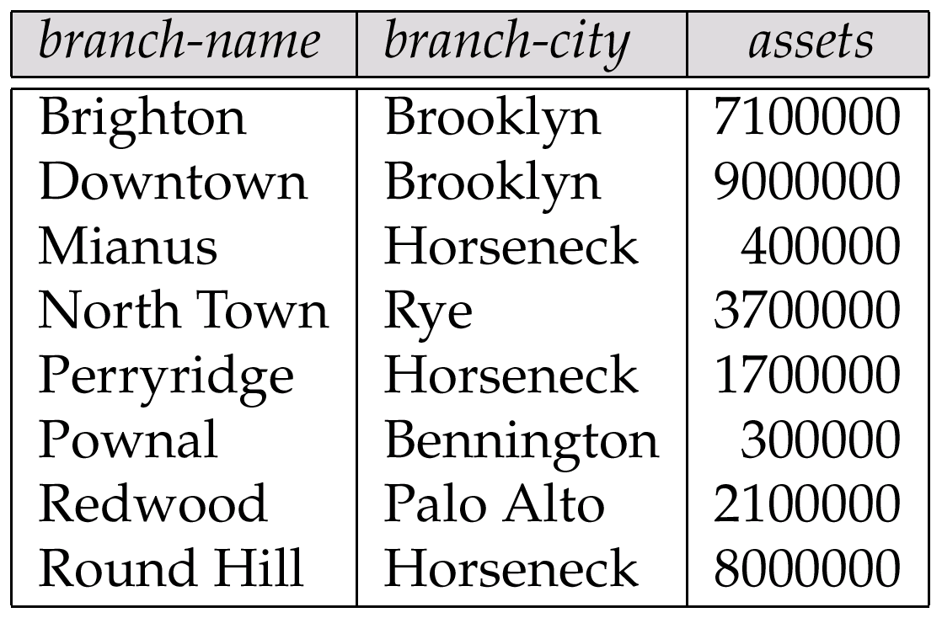
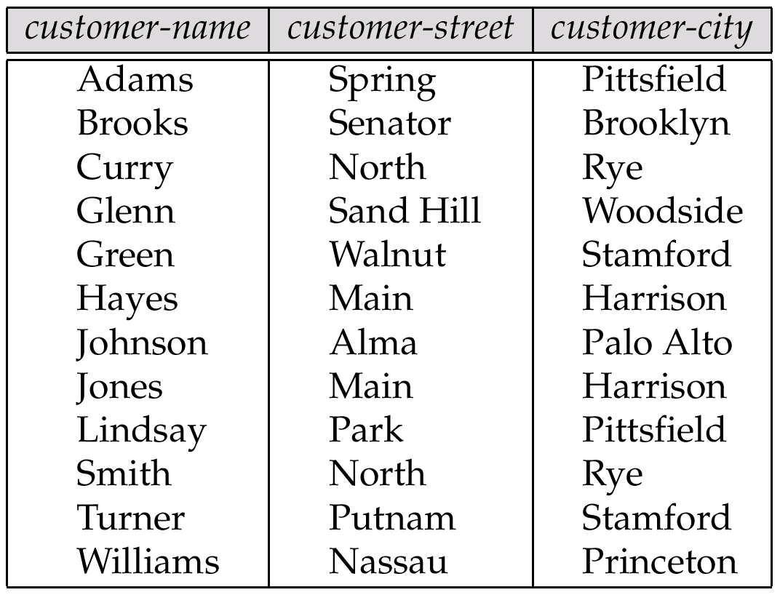

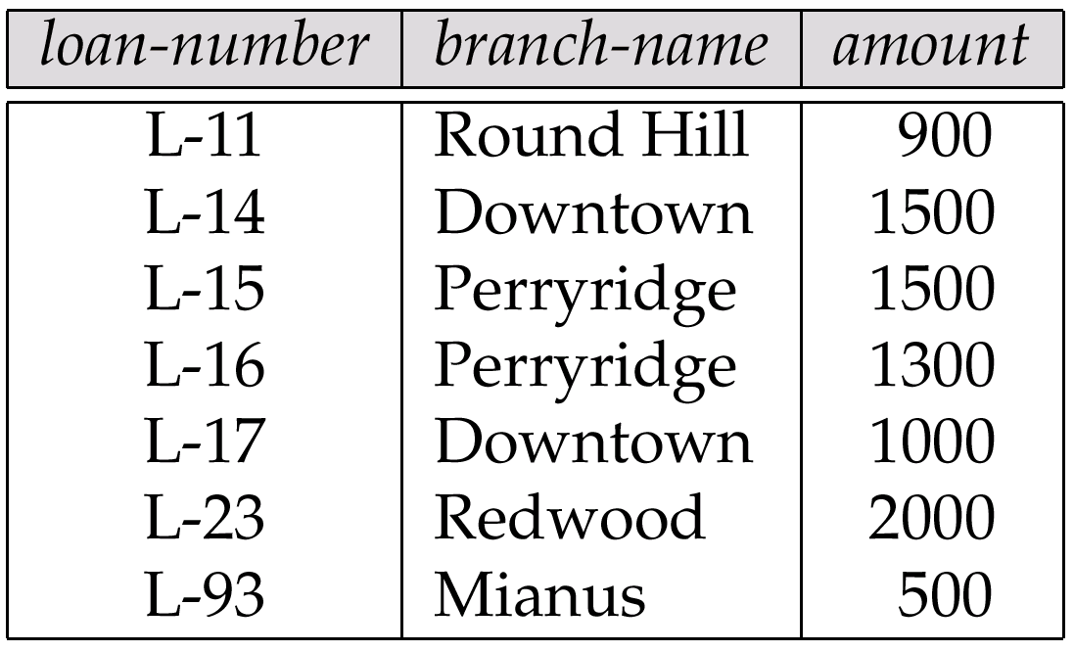
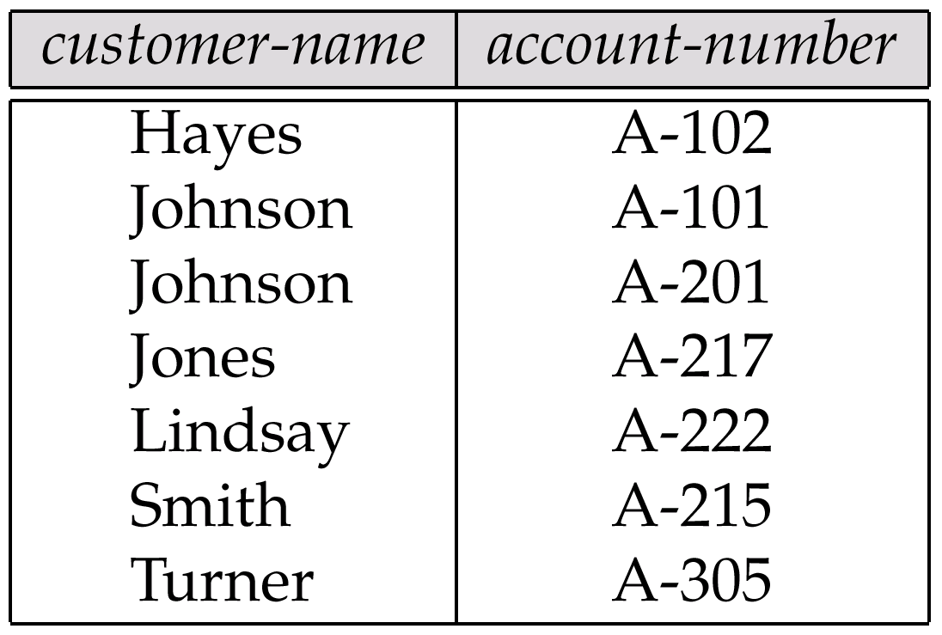
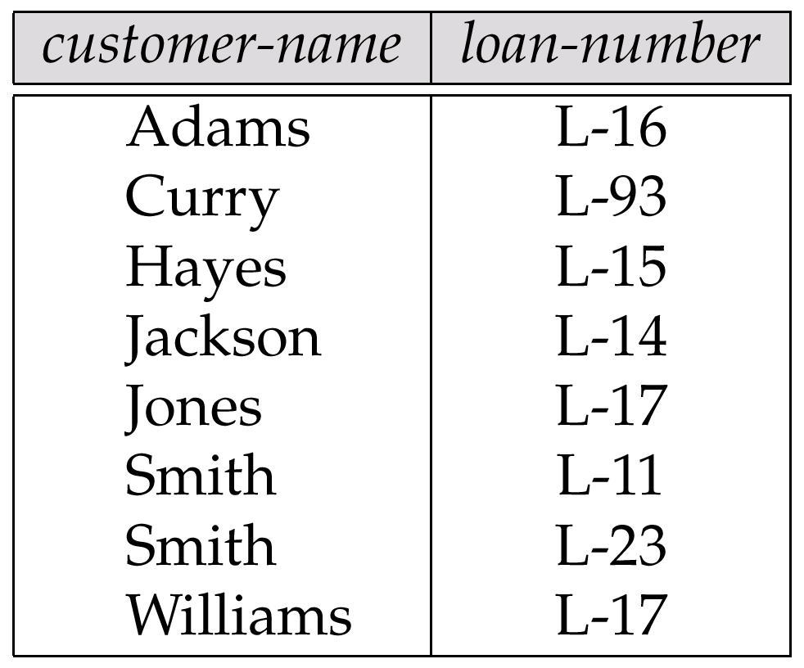
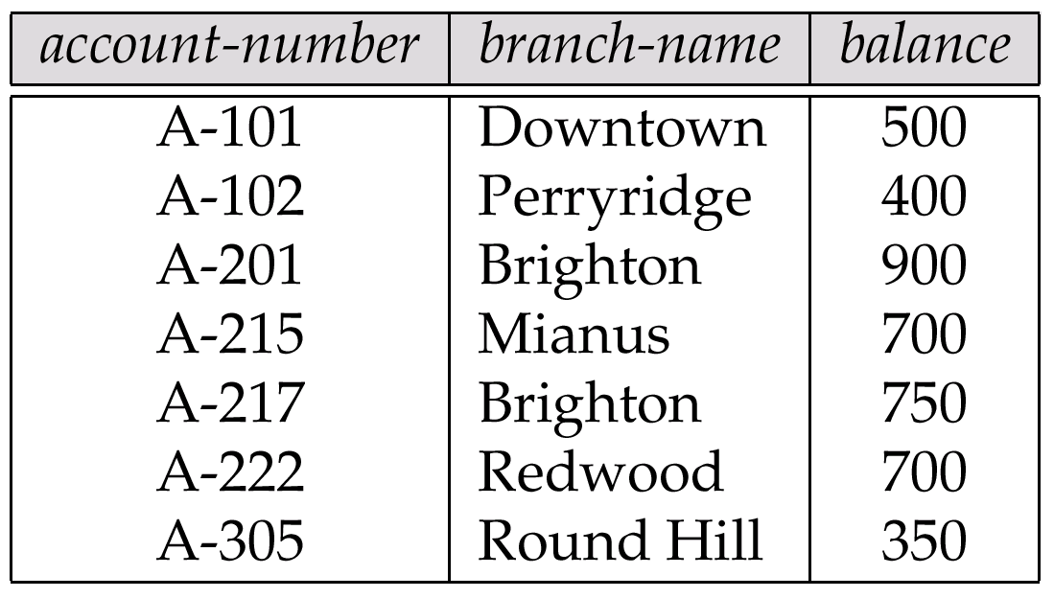
account
loan
depositor
borrower

